

|  |
| --- |
| Mediolanum / Misys |
| UCITS regulation: Global Exposure Calculation |
|  |

|  |
| --- |
|  |



Purpose 3

1 Exceptions to Global Exposure Calculations: Enhancements linked to the individual commitment (short term) 3

1.1 Barrier Options 3

1.2 CDX 3

2 Netting and Hedging Solutions: Order and Trade Entry screens 4

2.1 Order Entry Screen (short-term solution) 4

2.2 Order Entry Screen (long-term solution) 4

2.3 Pre-Trade Compliance checks (short-term) 5

2.4 Trade Entry Screen (short-term) 5

2.5 Position-level flag (short-term) 6

3 Post-trade Netting and Hedging validation widget (short-term) 7

3.1 New position criteria in the portfolio view 7

3.2 Layout of the widget 8

3.3 User Validation/Refusal 9

4 Computation of the Global Exposure 10

4.1 Short-term solution for the Net Commitment (editable column) 10

4.2 Long-term solution for the Net Commitment (hedging tree) 10

5 Computation of AIFMD leverages (short-term) 11

5.1 Gross Method 11

5.2 Commitment Method 12

# Purpose

The purpose of this document is to present the developments that should be done in order to assist the computation of the UCITS global exposure in FusionInvest where the system does not currently calculate global exposure exactly as outlined in the CESR’s Guidelines on Risk Measurement and the Calculation of Global Exposure and Counterparty Risk for UCITS and to facilitate netting and hedging calculations as part of the global exposure calculations. Features which are tagged as short-term developments are meant to be developed with the SDK, and thus could be available as soon as version 7.1.3. Features which are tagged as long-term solution are candidate to be part of a standard future version (at this stage we cannot commit on a timeline yet).

Regarding short-term developments, estimated costs are provided in the document. Please note that those estimated costs are pure development only, and do not include testing and deployment.

# Exceptions to Global Exposure Calculations: Enhancements linked to the individual commitment (short term)

*Estimated SDK development cost: 1 manday.*

## Barrier Options

The individual gross commitment is computed natively in FusionInvest for all derivatives described in the CESR documentation (this is subject to testing by the Medio Risk Team), except for ‘Partly Paid Securities’ and barrier options.

Regarding barrier options, the CESR formula involves the maximum delta of the option which can be extremely high.

However, when Mediolanum trades a barrier option, the value of the maximum delta is set in the terms of the contract. Therefore, a new field will be added in the instrument definition to be able to specify the maximum delta to be used in the individual commitment formula.

## CDX

CDX are not mentioned in the CESR documentation and are therefore absent from the derivatives covered by the native individual commitment column in FusionInvest.

The column will have to be enhanced so that it returns the aggregate notional value for the underlying CDS positions.

# Netting and Hedging Solutions: Order and Trade Entry screens

## Order Entry Screen (short-term solution)

*No SDK development required.*

Order properties (that are already available natively) can be configured to be used by the portfolio manager when creating an order on a derivative instrument:

* to notify his hedge intention,
* to log a comment about her decision.

Trader will not be able to change the ‘hedge-intention’ flag set by the portfolio manager.

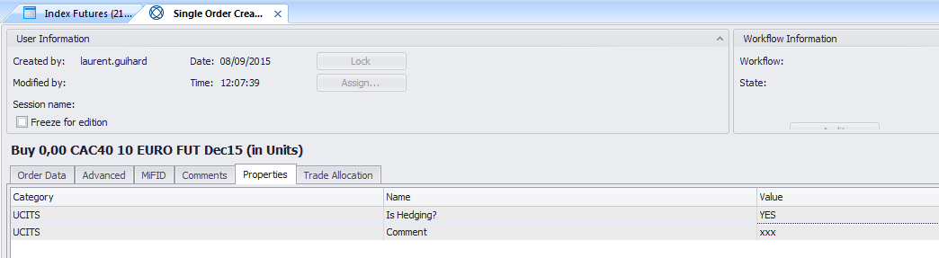

Figure : Order properties the Order Entry Screen

## Order Entry Screen (long-term solution)

Some fields will be added in a dedicated tab of the Order Entry screen. Those fields will be used when the portfolio manager creates an order on a derivative instrument.

There should be:

* A tickbox to specify whether the order is meant for hedging or not.
* The UCITS gross commitment of the order (as computed by FusionInvest).
* A dedicated textbox to log a commentary.

The edition of those fields will be audited.

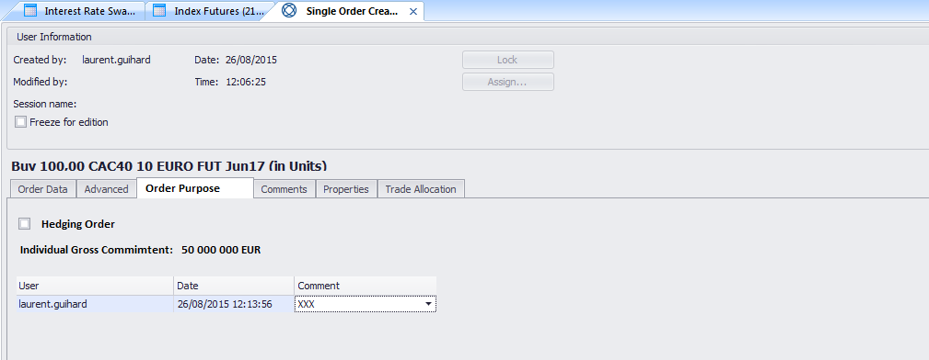

Figure : Mock-up of the new tab of the Order Entry Screen

## Pre-Trade Compliance checks (short-term)

*Estimated SDK development cost: 1 manday.*

Pre-Trade Compliance checks will be performed using the individual gross commitment of the derivative. To be clear, for pre-trade checks, the individual gross commitment of the new derivative order will be combined with the existing global exposure of the fund to ensure total global exposure is not greater than permitted limit as defined in the compliance rules.

## Trade Entry Screen (short-term)

*Estimated SDK development cost: 1 manday.*

Similar fields should be added to the trade entry screen:

* A tickbox called ‘Hedge Trade’ that will reflect the intention specified by the portfolio manager in the order.
* A ‘Comment’ textbox that will reflect the comment written by the portfolio manager in the order if any.

Those fields would be automatically populated from the corresponding order, would be considered as ‘FO fields’ in the trade workflow definition and would be audited.

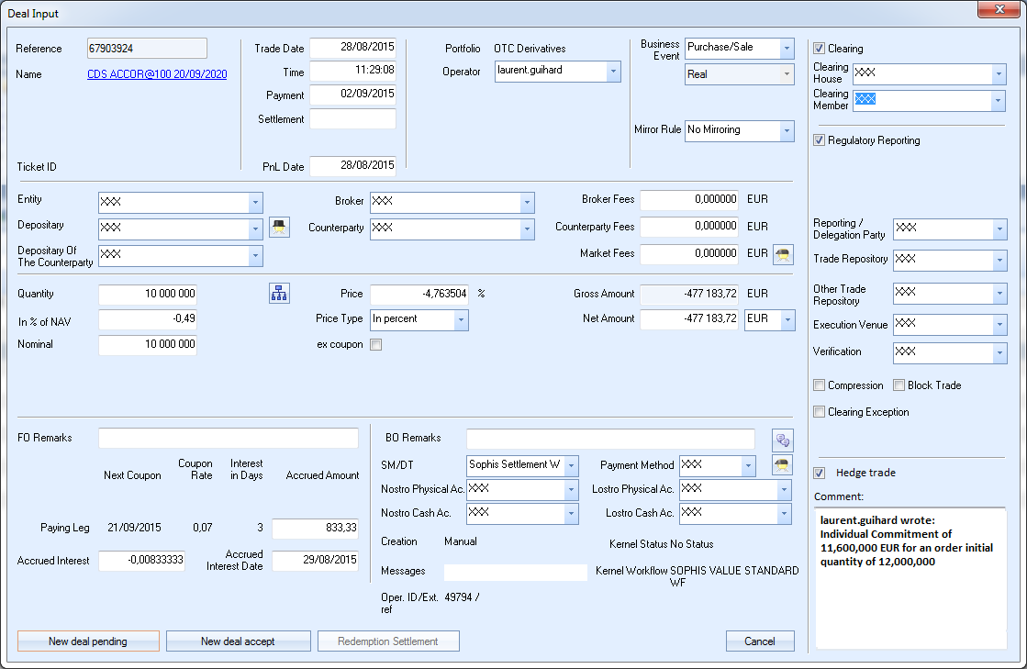

Figure : Trade Entry Screen

## Position-level flag (short-term)

*Estimated SDK development cost: 1 manday.*

 To avoid trade-based processes that would bring performance issues, the hedge intention should be retrievable at position level.

However, order information can only be transmitted at trade level. Therefore, a process (either automatically launched at End of Day, or manually launched) should be implemented in order to transmit the hedge flag at position level.

Moreover, it shouldn’t be possible to have in the same position 2 trades having different purposes (one hedging and one not-hedging).

To avoid this situation, 2 safeguards should be put in place inside that process:

* If an order flagged as ‘not hedging’ creates a trade on top of a position flagged as ‘hedging’, then the position flag will automatically be switched to ‘not hedging’ (conservative solution).
* If an order flagged as ‘hedging’ creates a trade on top of a position flagged as ‘not hedging’, then the position flag will stay to ‘not hedging’ (conservative solution).

# Post-trade Netting and Hedging validation widget (short-term)

*Estimated SDK development cost: 10 mandays.*

A post-trade validation widget should be created. The purpose of this widget will be to allow risk managers to validate or refuse the hedging character of positions that were marked as such by portfolio managers.

Positions will be selected in the portfolio view, and actions on those positions will be performed from the widget.

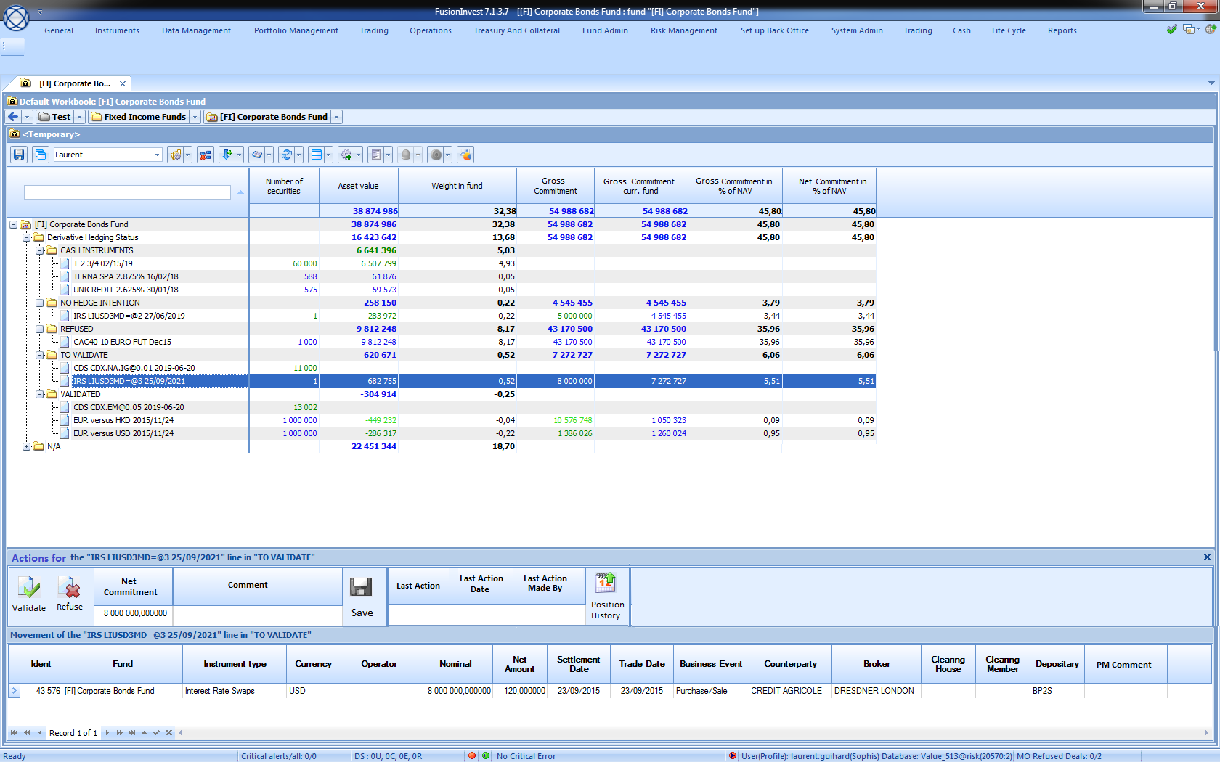

Figure : Mock-up for the post-trade netting and hedging validation widget

## New position criteria in the portfolio view

A new SDK position criteria should be created. It will allow sorting positions on derivatives in the portfolio view, depending on their ‘hedging’ status:

* Positions that are not meant to hedge: the portfolio manager didn’t tick the corresponding tickbox in any of the trades forming the position.
* Positions that are meant to hedge, and need to be validated as such by the risk managers.
* Positions that are meant to hedge, and have already been validated as such by the risk managers.
* Positions that are meant to hedge, and were refused as such by the risk managers.

## Layout of the widget

The widget should be split in two parts:

* The higher part should contain context-sensitive actions and information. When selecting a given position in the portfolio, the information displayed and the available actions (Accept, Refuse, Edit Net Commitment …) will adapt accordingly.
* When highlighting a given position in the portfolio, the lower part of the widget (also context-sensitive) should display the trades forming the position and should include a field displaying the comments from the PM from the orders.

The following information columns should be available in the higher part of the widget:

* Fund
* Instrument Name
* Individual Gross Commitment
* Net Commitment (editable)
* Hedging status of the position (Not Hedging, To be validated, Validated, Refused)
* Reason for hedging
* Last Validation/Refusal Date
* Name of the user who last validated or refused (only from Risk Management Team)

The following actions should be visible:

* Validate
* Refuse
* Enter a comment
* Save
* Position History

Those actions might be greyed out depending on the position selected in the portfolio view (see following paragraph).

The “Position History” will allow accessing all previous actions and comments for a given position.

Finally, the ability to refresh position-level flags (see paragraph 2.5) should also be available (not context-sensitive). Last time of refresh should also be displayed.

## User Validation/Refusal

For each derivative position, the risk manager will have the possibility to edit the net commitment for this position. This value would then populate a dedicated portfolio column.

Moreover, for each position marked as hedging by portfolio managers, the risk manager will have the opportunity to:

* Validate/Refuse a newly created position
* Validate a previously refused position, or refuse a previously validated position (if the portfolio situation has changed for instance)
* Re-validate a previously validated position, or re-refuse a previously refused position (to acknowledge the fact that the situation has not changed since the previous action).

Those actions will be deactivated for non-derivative positions or for derivatives positions not marked as hedging by portfolio managers (context-sensitive actions).

Any action should update the ‘Last Validation/Refusal Date’ field.

All validations/refusals should be audited and the risk manager should have the possibility to enter a comment for each action.

 For a given position marked as hedging, and whose status is either equal to ‘Validated’ or ‘Refused’, the booking of a new trade on that position should automatically (based on the Business Event of the trade) reset the status of the position to ‘To be validated’.

# Computation of the Global Exposure

## Short-term solution for the Net Commitment (editable column)

*SDK cost already included in the widget cost above (10 mandays).*

The post-trade validation widget should contain an editable column called ‘Net Commitment’. There should also be a portfolio column called the same way that would display in portfolio the values edited in the widget (and sum them up at the fund level).

## Long-term solution for the Net Commitment (hedging tree)

A dedicated part of the widget (another tab for instance) should allow the risk manager to build a hedging tree.

This tab should be split in two parts:

* The left part should contain the list of all securities present in the fund. It should be possible to sort/filter/group these securities by name, currency and instrument type.
* The right part should contain the list of all derivative positions present in the fund, flagged as ‘hedging’ by portfolio managers and validated as such by risk managers.

The risk manager should be able to drag & drop securities from the left part of the screen under the derivatives displayed in the right part of the screen. This would create a hedging node whose commitment would be equal to the difference between the individual commitment of the derivative and those of the plain positions.

(Net Commitment = Max (0 ; [Gross Derivative Commitment] – [market value of security positions] )

Derivatives marked as ‘not hedging’ by portfolio managers or refused by risk managers should also be displayed as they contribute to the global exposure of the fund.

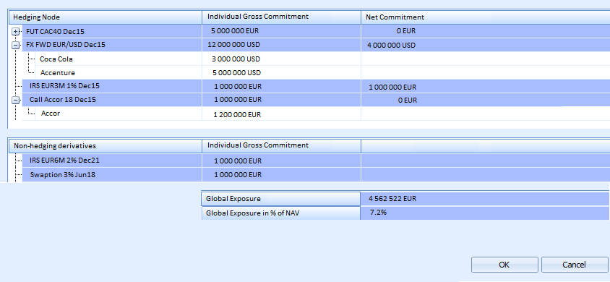

Figure 5: Hedging Tree

It should be allowed to drag & drop one given security under several derivatives (for instance, if it can net both FX and equity exposure).

Once all hedging nodes are correct, the risk manager should have the possibility to save the nodes and the resulting global exposure in database for this given date.

A column ‘Global Exposure’ should be added in portfolio and display for each derivative the value of its net commitment computed from the hedging tree.

A date t+1, the risk manager should retrieve the hedging tree saved at date t. He would then only have to adapt it based on the events that occurred in the fund during the last day (new derivative flagged and validated as ‘hedging’, security involved in a hedging node that has been sold …).

# Computation of AIFMD leverages (short-term)

## Gross Method

*Estimated SDK development cost: 1 manday.*

Two new columns will be developed:

* AIF exposure (Gross method)
* AIF leverage (Gross method)

The ‘AIF exposure (Gross method)’ column will return at fund level the absolute sum of:

* The values of any cash position present in the fund, and held in a currency different from the fund currency
* The market values of each non-derivative position present in the fund
* The UCITS gross commitments of each derivative position present in the fund

The ‘AIF leverage (Gross method)’ will be computed as the ‘AIF exposure (Gross method)’ column divided by the Fund NAV.

## Commitment Method

*Estimated SDK development cost: 1 manday.*

Two new columns will be developed:

* AIF exposure (Commitment method)
* AIF leverage (Commitment method)

The ‘AIF exposure (Commitment method)’ column will return at fund level the absolute sum of:

* The market values of each non-derivative position present in the fund
* The UCITS net commitments of each derivative position present in the fund

The ‘AIF leverage (Commitment method)’ will be computed as the ‘AIF exposure (Commitment method)’ column divided by the Fund NAV.

